Intro to ML 3: Unsupervised

Pre-Workshop Exercises



# What is Machine Learning?

*Q: What are the missing subsystems in the flowchart below?*

*Q: What do those subsystems do?*

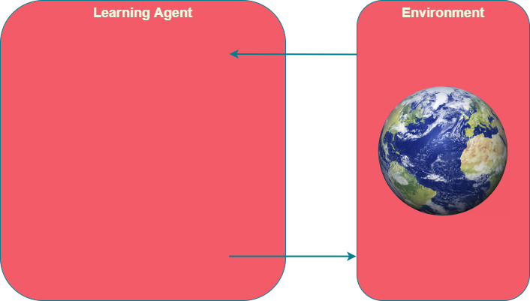

# Types of Machine Learning?

*Q: What are the three main types of machine learning?*

*Q: What was classification about?*

*Q: How is supervised different from unsupervised?*

# What are Features?

*Consider an abritrary model below that takes in features and outputs a prediction of whether the purchase is fraudulent or not. List five features you could use.*

*Rank the weights of the features from highest to lowest. Include whether the weights are positive, zero, or negative.*

Fraudulent

Purchase?

w1

w2

w3

w4

w5

# Where are the Clusters?

*Consider the graphs below. Outline the clusters.*

*How many clusters are there?*

*Highlight the outliers.*

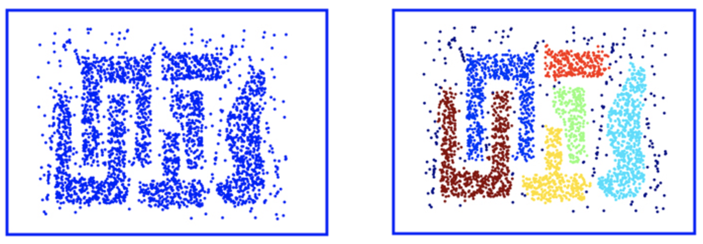

# Where are the Clusters?

*Consider the graphs below. Outline the clusters.*

*How many clusters are there?*

*Highlight the outliers.*

